Slow Twig

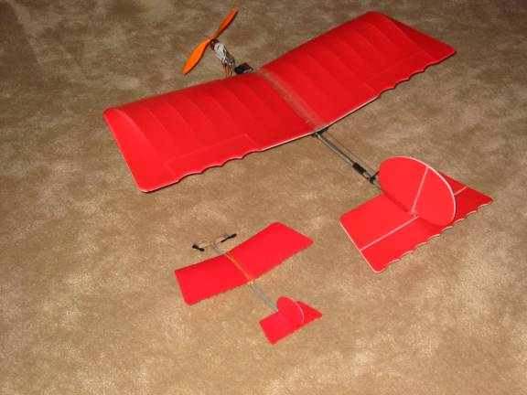
!/3 Scale model of the Slow Stick

Materials and Tools:

3 Foam plates form McDonald’s “Big Breakfast” bottom tray.
1/8” Balsa sheet
3/16” square balsa stick
Bamboo chopstick
Bamboo skewer
Aero Ace guts
Foam safe glue
3M Spray 77 adhesive
Rubber band
Scotch tape
Red water base spray paint
Silver magic marker
Black ink pen
Cardboard
Razor blade or Exacto knife
Scissors
Straight edge
Emery board, finger nail file

Procedure:

Make cardboard templates of the wing halves and the tail feathers. You can do this by printing the drawings and gluing (use Spray 77 Adhesive) to cardboard, then cutting.

Trace the templates on the foam plates.

Cut the foam wings and tail feathers out. Make sure your razor is very sharp toavoid tearing the foam as you cut.

Mark the hinge lines of the control surfaces with the black pen.

Curve the wings to match the camber in the wing support templates.

Spray paint the top surface of the foam pieces and both sides of the rudder with a light coat or red paint. The hinge lines will show through the paint. Let the paint dry.

Match the wing halves together. Block the wing tips up 1” for dihedral. The wings will touch in the very center but there will be a small gap at the leading edge and trailing edge of the of the match line of the two wing halves. Use an emery board to sand the wings where they actually touch until the gap is gone.

With the wings blocked up for dihedral, glue the two halves together using foam safe glue. After the glue is thoroughly dried, reinforce the joint with scotch tape on the top and bottom.

Cut the main fuselage stick 11 ½” long

Glue the horizontal stabilizer to the top of the stick using foam safe glue. The stick stops at the elevator hinge line.

Glue (foam safe glue) the rudder to the top of the horizontal stabilizer, match the rudder hinge line to the elevator hinge line.

Glue the wing supports to the side of the fuselage stick.

The gap between the horizontal stabilizer and the wing supports should be 4 inches.

Glue the battery and electronics support plate to the bottom of the main stick.

Cut a 3/8” length of bamboo chopstick and drill a cross hole for the skewer. This hole should provide a tight fit to the skewer.
Cut ½” square motor mount pads from the 1/8” balsa.

Cut a 4’ length of bamboo skewer.

Slide the skewer into the chopstick block…do not glue this joint. Glue the motor mount pads to the skewer.

Glue the bamboo block to the front end of the main stick. Be careful not to glue the skewer.

Color the balsa with the metallic marker pen.

Glue or tape the battery and electronics to the support pad.

Glue the motors to the motor pads. The propellers go to the back side of the motors.
When looking from the back of the plane, the motor that turns clockwise will go on the right side. This is so that the reaction torque from the propeller will help roll the plane in the right direction during a turn.

Glue short lengths of the 3/16” square balsa between the wing supports as shown in the photos. This will be used to hook the rubber band to hold on the wing.

Tape the wires in place.

Fasten the wing in place with a light rubber band.

Test glide with out power. Add weight to the nose or tail if required to get a good glide.

Rotate the skewer so that the propellers will provide about 10 degrees down thrust.

The lighter you can build the Slow Twig the better it will fly.

Your Slow Twig is ready to fly and tweak. Have fun!

Dan St.Louis
aka leadfeather
